Inspected by | TJF | Date | 4/3/2026

Sensor Information
ECO S/N | BBFL2WB-1755
RMA | 00001683
Types | ☐ Real time (-RT) or base  ☐ Battery (-B)  ☐ Wiper/ Shutter (-W or -S)  ☒ Battery AND Wiper/ Shutter (-SB or -WB) | ☐ -AP2/ -RT2K  ☐ Deep (-D/-RT6K/ -6K)  ☐ -SLC  ☐ Puck
Number of Channel | 3
Channel 1 | NTU
Channel 2 (if applicable) | CHL
Channel 3 (if applicable) | CDOM

Hardware/ Parts
RT, Base, Shutter unit | Shutter/ Wiper unit | Battery unit | -SLC unit
☐ Mounting bracket | ☒ Copper face plate  ☒ Copper Shutter/ Wiper | ☒Dummy battery plug/ collar | ☐ Copper face plate  ☐ Molex cover
-AP2 unit | -RT2K unit | Deep unit | CDOM unit only
☐ Anode  ☐ Saddle | ☐ Anode | ☐Max 6000m label | ☒ UV warning label

☒ | Lock collar, dummy plug/ collar
☒ | Protective end cap has same SN as the unit
☒ | Serial Number Label

Physical Inspection
☒ | Sensor SN listed above matches with the label on the unit
☒ | Fishing line is present in slot
☒ | Connector pins on bulkhead are not corroded
☒ | Optics window has no crack, obvious debris,
☒ | Wiper/ Shutter unit: Rubber blade(s) from wiper/ shutter are contacting the optics surface
☒ | Bulkhead tightened

Documentation
USB | ☒ Check that USB folder’s name includes unit SN
Manuals | ☒ Sensor user manual  ☒ Triplet-W Manual  ☒ ECOView software  ☒ ECOView user manual
Char Sheets |  | Channel 1 | Channel 2 | Channel 3
 | Date | ☒ | ☒ | ☒
 | S/N | ☒ | ☒ | ☒
 | Temp | ☒ | ☒ | ☒
 | Dark Counts | 50 | 49 | 50
 | Dark Count (40-70)  (CDOM: 40-80) | ☒ | ☒ | ☒
 | Analog Darks (V) | N/A | N/A | N/A
 | Scale Factor != 1 | ☒ | ☒ | ☒
 | Saturation | 4130 | 4130 | 4130
 | ☐ Char Sheet for Post-cruise and/or Secondary calibration (if applicable)

Documentation (Continued)
Device File | ☒ Device file present and labeled with sensor SN  ☐ Single Channel FL contain both:  ☐ Dev File  ☐ ENGR Dev File  ☐ AP2 only: use OEM dev file  ☐ 2 Channel = 5 blank columns in dev file  ☐ 3 Channel = 7 blank columns in dev file  ☐ SLC & Puck & RT2K only:  ☐ 2 Channel = 7 columns in dev file  ☒ 3 Channel = 9 columns in dev file
Triplet-W only | ☒ “TripletW.zip” file  ☒ “Triplet-W setup commands”
Repair Sheet | ☒ Repair sheet  ☒ Correct S/N in Repair Sheet
Final USB Check | ☒ Verify no other files are in USB Folder  ☒ QA Checklist IS NOT in USB Folder

Functionality (Open EcoView)
Saturation in EcoView | 4130 | 4130 | 4130
Saturation equal to Char Sheet | ☒ | ☒ | ☒
Dark AVG  from “D” file | 50 | 48.98 | 50
Dark Value =  Char Sheet | ☒ | ☒ | ☒

☒ | Verify Saturation:  - 16380 for 1ch FL / 1 ch NTU units  - 4130 for 2ch, 3ch, and 1ch BB
☒ | Verify that serial number shown in EcoView output is correct
☒ | Return Settings to Incoming Settings
☐ | Clear memory (if applicable) $emc
☒ | Internal battery voltage (8.5V min)

Functionality (Open EcoView) (Continued)
1Ch Chlorophyll unit only: | ☐ |  | Use $par and verify that ugl matches scale factor and off matches dark counts
FLBBFL-/ TripletW units only | ☒ |  | Use $par and verify that offset M1d, M2d, M3d in unit menu is as written in dev file
 | ☒ |  | Use $par and verify that scale factor M1s, M2s, M3s in unit menu is as written in dev file
CDOM unit only |  | ☒ | Passing result for CDOM test (in main unit folder)

Oracle
SBE Service Depot Repair > Repair Orders > Enter RMA > Select Instrument
☒ | Verify Repair Sheet content matches Debrief Notes
☒ | Verify Repair Sheet content matches customer request in the “Preliminary Service Quote Request” email in the Job Folder
☒ | Verify correct S/N on Repair Sheet
☒ | Verify “Material Consumed” matches Repair Sheet
☒ | Place USB folder into Job RMA Folder (linked in Oracle)
☒ | Change status to Done in Oracle
☒ | Enter in Description line: “PASSED QA” – INITIALS- DATE

Administrative
☒ | Update info into QA Log Book

Screen shot of the EcoView Raw Data
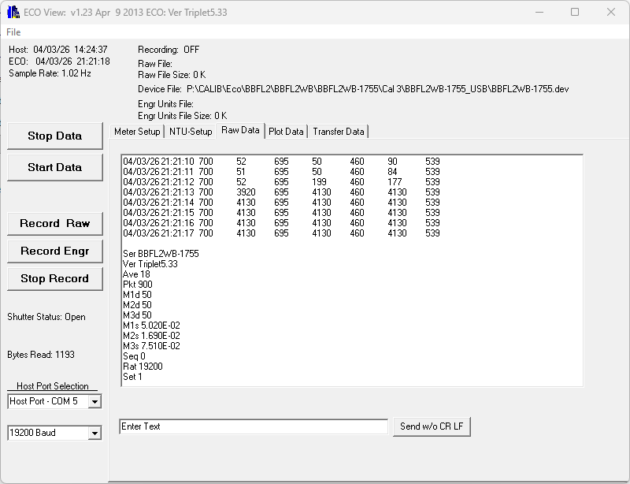

Screen shot of the EcoView Setup Tabs
